QUESTIONS by ML 260619

## Correlation

1. Justin wrote: “The correlations don't use as many variables that aren't interesting, so it cleans up their presentation”. I am sorry, but I don’t understand the sentence. If it means that you Justin don’t provide us the exact correlation coefficients I have requested, how do we report these balls? Blue is what? Red? Small ones? Big ones?

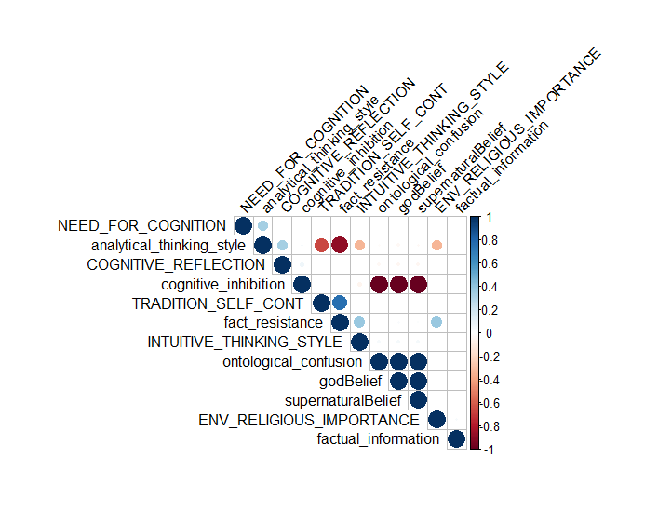

2. Now, when fact resistance is included (with need for cognition and cognitive reflection), why also analytic thinking style is included? There is no other analytic style than those three.

3. Many variables are missing: trauma, family, culture, presence of atheist, level of education and study topic. We have to report correlations for all variables whether they were low or high. These are needed not only by the journal but also because I am not able to write or think about the discussion without more exact information.

## Regression

We also utilized regression to understand the positive and negative effects of different variables on god beliefs and supernatural beliefs.

In order to better understand the key variables of our model, we can trim down to just the most important variables from the literature. This regression results are found below.

4. Why not from the correlations? It would be extremely difficult to justify this by ‘the literature’ and it is a normal way to exclude variables that do not correlate with the dependent variable.

|  |  |  |  |
| --- | --- | --- | --- |
| Variable | Beta (standardized) | t | p |
| INTELLIGENCE | -0.0039 | -199.49 | <.01 |
| TRAD_SELF_CONT | 0.0039 | 115.22 | <.01 |
| INTUITIVE_THINKING_STYLE | 0.0019 | 79.30 | <.01 |
| COGNITIVE_REFLECTION | -0.0039 | -194.13 | <.01 |
| NEED_FOR_COGNITION | -0.0039 | -199.77 | <.01 |
| Fact_resistance | 0.016 | 421.99 | <.01 |
| Cognitive_inhibition | 0.00034 | 1.80 | .07 |
| Ontological_confusion | 0.99 | 5243.04 | <.01 |

General model statistics: *RSE* = 2.05, *df* = 19991, *r2* = 1, *f* = .000000032(8,19991), *p* < .01.

5. The results are not sensible. Ontological confusions cannot explain everything (they can’t have a beta which is 250 times higher than the beta of the other variables)

We were somewhat surprised to see the insignificant relationship with cognitive_inhibition in the data. To further investigate our system we used the Lavaan package to create an SEM of a mediation model to test that the relationship between ontological confusion and god beliefs was mediated by cognitive inhibition. Indeed, we found that the relationship between cognitive inhibition and god beliefs is mediated by ontological confusion and that this relationship can be expressed as a full mediation model.

6. Which model was tested, green or blue? The green model is not sensible, but the blue is.

7. If the blue model was tested (as the figure hints), how can we justify this? Cognitive inhibition did not predict God belief, so there is no reason to examine what explains this relationship (because there is no relationship). However, cognitive inhibition had a big red ball for both God belief and ontological confusions in the correlation matrix. Do they indicate strong relationships? If yes, we might justify the SEM by these associations, or?

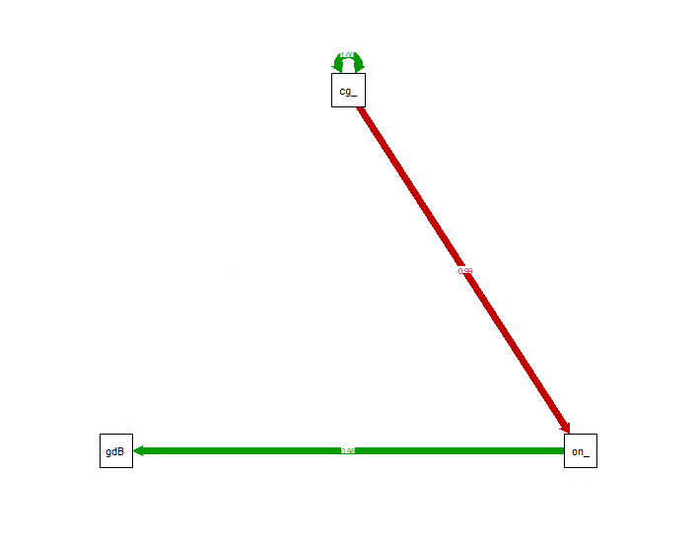

# Optimization

* For Tommy only

# Calibration



8. These results are scary strange. For example, traditional values and intuitive style ‘explain’ both the conversion from religious to atheist and from atheist to religious etc. I hope that the explanations for this table Justin promised to write clear things up.

**9. PLEASE JUSTIN, tell us the reason why ontological confusions are not included! I know that this is one of the hundred times asked questions, but the response that ontological confusion is a parameter is just not enough**. I repeat myself: “. So please, I would really appreciate it if I could get some … text sections about these issues intended to be included in the manuscript (keeping in mind the intelligence researcher R. Sternberg’s tip to get articles published: ”Write for a somewhat broader and technically less skilled audience than you expect to read the article”).”

10. And also in general, the variables included in this analysis should either be exactly the same as in the correlation table, or the exclusion of some variables should be clearly justified.

# Key Features

Our AI system determined that, when classifying a person, based on the input parameters, as a “believer” or “nonbeliever” that the top-5 most important data in determining the classification decision are from the following variables (ranked in order of importance):

Cognitive inhibition

Analytical thinking style

Tradition and self continuity

Frequency of trauma

Presence of atheists

11. As we discussed when we skyped, the results for this believer-nonbeliever classification are quite different from the regression analysis results (which is of course logical, for the most part). Justin told that the reason is that the relationship between the predictors is asymmetrical for believers and unbelievers. Is there any way to examine how? Or should we just write in the Discussion, that “the predictors were asymmetrical for believers and unbelievers but we have no idea how”?

12. What about the flows? They were included in the early version, and they caused me great headache when writing the Introduction. Is there a similar flow table coming up?

When I get answers to all (literally all) these questions, I am eager to write the draft for the Discussion 😊.